KJV Edition | Exodus 23:23 | Changes relative to 1st edition 1611
Bishops Bible 1568 | 23 For myne angell shall go before thee, and bryng thee in vnto the Amorites, and Hethites, and Pharezites, & Chanaanites, Heuites, and Iebusites, and I shall destroy them. | - The “a” in Angel made lowercase
The Great Bible 1541 (no verse numbers) | 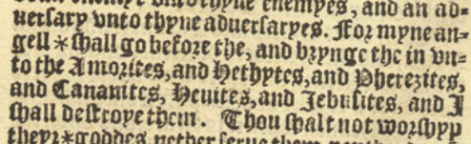  (23) For myne angell shall go before thee, and brynge thee in vnto the Amorites, and Hethytes, and Pherizites, and Canaanites, Heuites, and Iebusites, and I shall destroye them. | - The “a” in Angel made lowercase
1560 Geneva Bible (protestants) | 23 For mine Angel shall go before thee, & bring thee vnto the Amorites, and the Hittites, and the Perizzites, and the Canaanites, the Hiuites, and the Iebusites, and I will destroy them. | - & instead of and  - missing “in” between “thee vnto”  - Comma instead of colon after lebusites  - “I will destroy them” instead of “I will cut them off.”
The Holy Bible King James 1611 The First Edition Imprinted by Robert Barker  First editions can be identified by Ruth 3:15b “and he went into the citie” instead of “she went into the citie” | 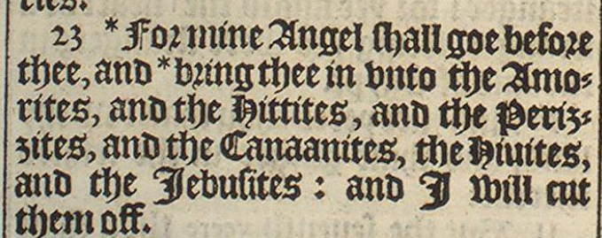  23 For mine Angel shall goe before thee, and bring thee in unto the Amorites, and the Hittites, and the Perizzites, and the Canaanites, the Hivites, and the Jebusites: and I will cut them off.
The Bible (Robert Barker 1616) | 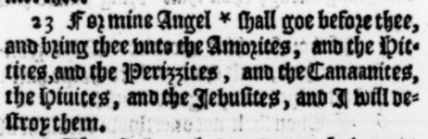  23 For mine Angel shall goe before thee, and bring thee unto the Amorites, and the Hittites, and the Perizzites, and the Canaanites, the Hivites, and the Jebusites, and I will destroy them. | - “in” removed  - Colon changed to a comma after Jebusites  - “cut them off” changed to “destroy them”
The Bible “Printed by Thomas and John Buck printers to the University of Cambridge” 1629  NOTE: many heretical doctrines preceding the Biblical text  Edited by: Samuel Ward and John Bois (supposedly to correct errors introduced in early printings) | 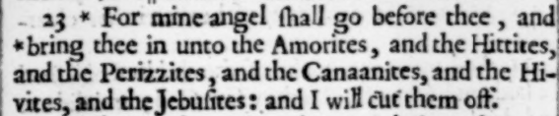  23 For mine angel shall go before thee, and bring thee in unto the Amorites, and the Hittites, and the Perizzites, and the Canaanites, and the Hivites, and the Jebusites: and I will cut them off. | - The “a” in Angel made lowercase  - “e” removed from goe  - “and” added before “the Hivites”
The Holy Bible Universitie of Cambridge, 1637  (HathiTrust)  Printed by Thomas Buck & Roger Daniel | 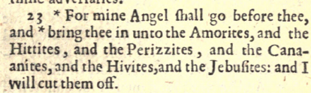  23 For mine Angel shall go before thee, and bring thee in unto the Amorites, and the Hittites, and the Perizzites, and the Canaanites, and the Hivites, and the Jebusites: and I will cut them off. | - “e” removed from “goe”  - “and” added before “the Hivites”
Oxford 1675 (couldn’t find digital version) | Appears to have the same Catholic bondage and heresies inserted before the Biblical text as the Cambridge 1637 edition
The Holy Bible  1769 Oxford edition | 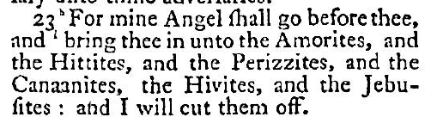  23 For mine Angel shall go before thee, and bring thee in unto the Amorites, and the Hittites, and the Perizzites, and the Canaanites, the Hivites, and the Jebusites: and I will cut them off. | - “e” removed from “goe”
Authorized King James Version  Pure Cambridge Edition (Bible protector) | 23 For mine Angel shall go before thee, and bring thee in unto the Amorites, and the Hittites, and the Perizzites, and the Canaanites, and the Hivites, and the Jebusites: and I will cut them off. | - “and” added before “the Hivites”

